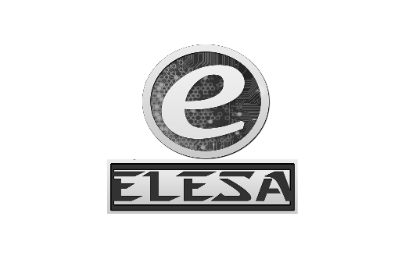WALCHAND COLLEGE OF ENGINEERING, SANGLI

**ELESA**

**ELECTRONICS ENGINEERING STUDENTS’ ASSOCIATION**

DATE:

To,

Dr. B. G. Patil,

Dean Students Welfare,

WCE, Sangli.

SUBJECT: Regarding permission for organizing mega event ‘ELECTROVERT’ on 17th and 18th September, 2016 and campaigning of it.

Respected Sir,

On 17th and 18th September, ELESA is planning to organize a two day-event **‘ELECTROVERT’**. This event will comprise of nine different sub-events. It is a state level technical event, so we expect huge response as before.

That is why we urge you to grant permission for conducting this event. Also grant us the permission for the campaigning of our event. For campaigning, we would be requiring a counter, displaying our poster on the notice board and announcements in the classrooms.

ELECTROVERT comprises of many different technical competitions related to the different engineering fields. It will surely help the students in not only developing their technical skills, but also in dynamically shaping their personalities.

Also, we assure you that our presence will not cause any hindrance to the academic works of the college.

Yours sincerely,

Approved By,

Dr. G. V. Parishwad,

Director,

WCE Sangli.

OSD, Students Welfare,WCE

**HOD**

Dr. B. G. Patil

**Staff Advisor**

Dr. S. D. Ruikar

**President**

Amol Gaykhe

*president@elesa.in*

**Vice-President**

Pavan Chopade *vicepresident@elesa.in*

**Event Director**

Rukkaiyya Shekh

*event@elesa.in*

**Technical Director**

Vidya Mane

*technical@elesa.in*

**Club Service Director**

Tejashree Chougule

Saraswati Solage

*csd@elesa.in*

**Web Developer**

Narsing Mundhe

*webadmin@elesa.in*

**Treasurer**

Samrudddhi Kulkarni

*treasurer@elesa.in*

**Aptitude Developer**

Tejashree Chougule

Saraswati Solage

*aptitude@elesa.in*

Dr. B. G. Patil

H.O.D., Dept. of Electronics

Dr. S. D. Ruikar

Staff Advisor, ELESA

Amol Gaykhe

President, ELESA

Dr. B.G. Patil

Dean Students Welfare,

WCE Sangli.